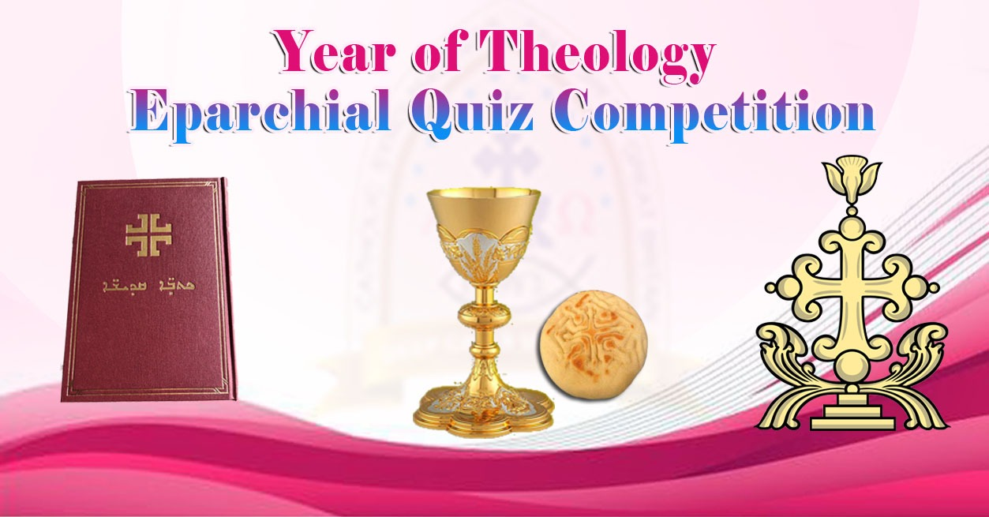

Week 4 ( January 07_2024)

1.​Who comments; “Father, Son and Ruha d’Kudsha can be reached only by their names; do not look further, to their persons (Persopa), just meditate on their Names. If you investigate the person of Alaha, you will perish, but if you believe in the Name, you will live.”?
Mar Aprem.

2. Which is the prominent Theological School along with School of Antioch?
School of Alexandria.

3. Which school was also known as "Christology from Above"?
School of Alexandria.

4. Why Alexandrian School was known as Christology from Above?
There Christology was centred on Word of Alaha, Logos.
The Christology of the school of Alexandria was centred on the theme ‘word became flesh. The word of God became the historical Jesus Christ. Alexandrians did not sufficiently stress the humanity of Christ.

5. Which school was also known as "Christology from Below/ Ascending Christology"?
School of Antioch (East Syriac Theology).

6. Why Antiochian School was known as Christology from Below?
There Christology was centered on Historical Isho M'shiha of Nazareth, and ascended to affirm the Divinity of Lord.
The Christology of the School of Antioch that East Syriac Church followed is the word- man Christology. It starts with historical Jesus Christ and affirm the divinity of the Lord. It did not divide Jesus Christ in to two persons but gave sufficient emphasis on humanity as well.

7. Who can be considered as the best representative of the School of Alexandria?
Mar Cooriloe (Cyril of Alexandria).
Cyril of Alexandria (Coorillose)

8. Who were the prominent teachers of School of Alexandria?
Mar Clement, Mar Origen, Mar Athanasius, and Mar Theophilus.

9. "Divinity is not received from the Mother nor Humanity is received from the Father. Both natures are miraculously joined together in Isho M'shiha" Where can we find this in East Syriac Liturgy?
Teshbohtha, Lelya, First Monday of Suvara.

10. What was the topic emphasised in Sunnahadose of Ephesus (431)?
Divinity of Isho M'shiha.

11. What was the topic emphasised in Sunnahadose of Chalcedon (451)?
Full Humanity of Isho M'shiha.

12. How was the approach of the Alexandrian School to the Mystery of M'shiha?
They stressed on unity of two natures in the person of M'shiha.

13. How was the approach of the Antiochian School to the Mystery of M'shiha?
They emphasized on distinction of two natures and their characteristics in the one person of Isho M'shiha.

14. Who is the "Architect of Creation" according to Mar Aprem?
Ruha d'Qudsha.
15. Who calls Ruha d'Qudsha as the"Treasure of Life"?
Mar AbdIsho Hazzaya. (7th Cent.)

16. How does Mar Narsai describe Ruha d'Qudsha?
Heavenly Treasure.

17. Who compares the Holy Trinity to the Sun, Father as the Sun, it's light as the Son and it's heat as Ruha d'Qudsha?
Mar Aprem.

18. Who teaches: "The Fire of Ruha d'Qudsha is the divine impulse in human affairs"?
Mar Abdisho Hazzaya.

19. Does East Syriac tradition accept the Council of Ephesus?
No

20. When did Church of the East accept nicean council of 325?
410 - During council of Mar Isaq

Week 4 ( January 07_2024)

